Safety Committee Meetings Summary

The Safety Committee met (monthly/quarterly/or number of times during current year). There are (X number) of committee members and our attendance rate is approximately [add rate of attendance here]. [Note whether increase/decrease in attendance from previous year, Chair attendance/participation in OSHC or ISHCC quarterly meetings, whether the Scientific Director or designee attended any of the meetings and committee focus/goal of current year]

Summary of Safety Committee Activities
Include summary of safety committee activities including any safety complaints received/addressed by the committee.

List of Current Safety Committee Members:
List can be attached at end of document.

Summary of Safety Training Compliance:
(Lab Managers have access to obtain data, contact Safety Specialist for data if needed).
Percent of employees compliant with Lab Safety Training:
Percent of Employees compliant with Bloodborne Pathogen Training:

Summary of Injuries/Incidents: (Contact Safety Specialist to obtain data, if needed)
[List number of injuries and commentary on any patterns (frequent injuries, etc.), significant injuries, and attempts to address any patterns]

Onboarding and Offboarding of PI’s:
[List the names of any new or offboarding (retiring, leaving, transferring, etc.) PIs in your IC during the calendar year]

Summary of Registered Lab Survey Findings: (Contact Safety Specialist for data, if needed)
Number of survey findings:
Number of findings remediated:
Overall percent of findings remediated:

Scorecard Data: (Will be provided by SOSB Branch Chief)

[Summarize relevant scorecard data received from the SOSB Branch Chief for the previous year and note any action items completed or planned based on scorecard data for the current and/or upcoming year]

Safety Committee Goals for Upcoming Year and Action Plan
[Describe safety committee goals (use SMART goal technique) and action plan for the upcoming year. For example, review injury data trends to identify a focus for prevention of common injuries for the upcoming year].

Summary of IC Safety Committee Surveys
The [IC name] Safety Committee surveyed [enter number] of unregistered laboratory spaces, [enter number] of corridor spaces, and [enter number] of office spaces in [year]. The sections below summarize the individual categories noting the total number findings as well as any trending observations.

Summary of Safety Committee Unregistered Lab Surveys
[Insert chart from excel spreadsheet template]

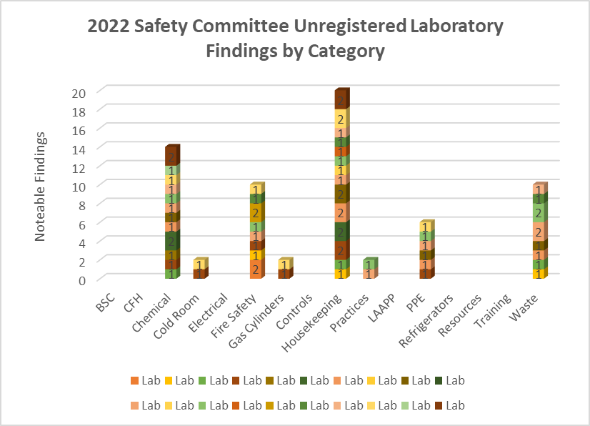

Summarize general findings of unregistered lab survey results. Include total number of possible findings and total number of findings for entire institute. Note major findings and their category as well as if there were categories that had no findings.

EXAMPLE TEXT: There were [total number of survey categories on DOHS unregistered lab survey form] survey categories with a potential of [total number of possible findings on the DOHS unregistered lab survey form] notable findings per space. [Year] yielded a total of [number of total findings for entire institute] documented findings with the majority noted in [list whichever categories had most findings]. *Note any categories that had no findings

Summary of Safety Committee Corridor Surveys
[Insert chart from excel spreadsheet template]

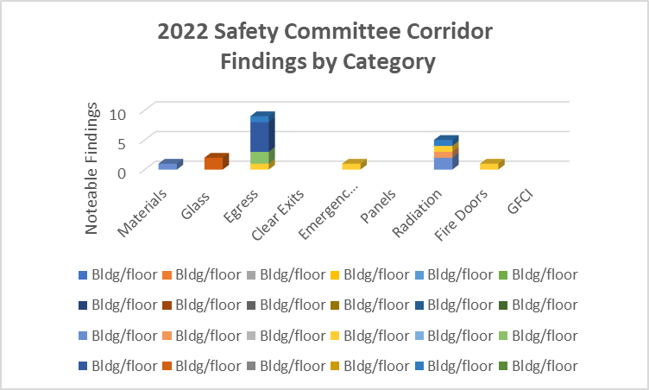

Summarize general findings of corridor survey results. Include total number of possible findings and total number of findings for entire institute. Note major findings and their category as well as if there were categories that had no findings.

(EXAMPLE TEXT BELOW CHART): [Year] Safety Committee Corridor Findings by Category:

There were [total number of corridors surveyed] corridors surveyed in [year]with a total of [number of total findings for entire institute] documented findings with the majority noted in [list whichever categories had most findings]. [Note if there were any categories that had no findings].

Summary of Safety Committee Office Surveys
[Insert chart from excel spreadsheet template]
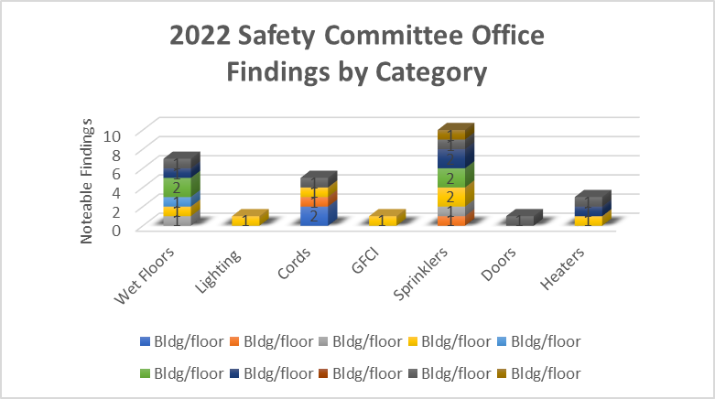

Summarize general findings of office survey results. Include total number of possible findings, total number of findings for entire institute. Note major findings and their category. Note if there are any categories that had no findings.

EXAMPLE TEXT BELOW CHART): [Year] Safety Committee office findings by category:

There were [total number of office spaces] offices surveyed with a total of [number of total findings for entire institute] documented findings with the majority noted in [list whichever categories had most findings]. [Note if there were any categories that had no findings].

Overview of Unregistered Lab Survey Data for 3 Year Comparison
[Insert chart from excel spreadsheet template]
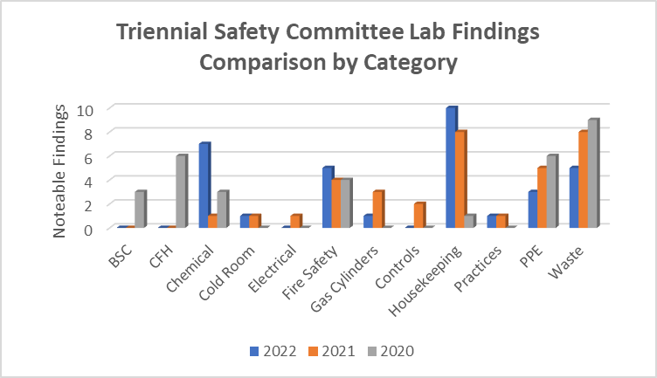

Use table below to document total findings per year and total number of areas surveyed each year.

2020 | 2021 | 2022
Total observations = 36  Areas surveyed = 15  Total possible observations = 540 | Total observations = 32  Areas surveyd = 14  Total possible observations = 540 | Total observations = 35  Areas surveyed = 14  Total possible observations = 540

Summary of Safety Committee Findings
Summarize findings to include areas of improvement, plan to resolve remaining findings, restrictions or roadblocks to resolution to resolution that occurred or are anticipated.

Table 1: (Total number of labs/PIs) surveys were conducted.
Biological Safety Cabinet (BSC) | Corrective action indicated | Comments
Are BSCs certified within the last year? | 1 | Total number of findings out of possible number of observations out of total lab areas  Example text for summary:  1 of 56 possible observations noted  amongst 14 labs surveyed
Are front grill and exhaust filters unobstructed? | 0
Are open flames not used inside the cabinet? | 0
Do vacuum traps on floors have secondary containment? Do vacuum lines have in-line filters? | 0
Chemical Fume Hood (CFH) and Other Local Exhaust | Corrective action indicated | Comments
Have CFHs received certification within the last year? | 0 | No corrective action indicated (only added for categories where no Labs/PIs had findings in any of the questions)
Are air foil and rear baffles unobstructed? | 0
Is the sash at or below the maximum height? | 0
Is the CFH free from any blockage or obstructions? | 0
Has other required local exhaust equipment been certified (e.g., downdraft tables, etc.)? | 0
Chemicals | Corrective action indicated | Comments
Are all flammables stored in a flammable storage cabinet? | 0 | No corrective action indicated
Have peroxide formers been double dated? | 0
Have chemicals been segregated properly? | 0
Are no hazardous materials stored above eye level? | 0
Are all chemical containers within laboratory securely closed? | 0
Are all solutions properly labeled? | 0
No mercury thermometers are present? | 0
Cold Room | Corrective action indicated | Comments
Does cold room have an emergency release? | 0 | No corrective action indicated
Is emergency POC info present on the outside of the unit? | 0
Is there any excess, unused, or damaged cardboard stored in the cold room? | 0
Asphyxiates and hazardous gases are not present or used? | 0
Electrical | Corrective action indicated | Comments
Are all equipment without frayed or damaged wiring? | 0 | No corrective action indicated
Are all outlets or electrical strips used in the laboratory not overloaded? | 0
Are all computers/power strips mounted off the floor? | 0
Are electrical outlets within 1 meter of water sources protected by G.F.C.I? | 0
Are there no portable space heaters? | 0
Are there no permanent extension cords? | 0
Are electrical panels accessible? (Unblocked within  36” of panel) | 0
Fire Protection | Corrective action indicated | Comments
Are sprinkler heads free of obstructions with an 18" clear plane below sprinkler heads? Fire extinguishers not blocked? | 0 | No corrective action indicated
Are all passage widths in laboratory a minimum of 36"? | 0
Are doors to labs and hazardous storage kept closed to ensure fire protection and directional air flow? | 0
Are all excess combustibles stored elsewhere outside of laboratory? | 0
There are no open penetrations in the walls, floor, or ceiling (e.g., ceiling tiles missing etc.)? | 0
Gas Cylinders | Corrective action indicated | Comments
Are all cylinders properly secured? | 0 | No corrective action indicated
Are the caps on all reserve cylinders? | 0
There are no excess or empty cylinders in the laboratory? | 0
General Engineering Controls | Corrective action indicated | Comments
Is laboratory air flow negative to general occupancy, corridor & office areas? | 0 | No corrective action indicated
Is hand washing sink available near laboratory exit? | 0
Do vacuum lines on lab benches and in BSCs have in-line filters and disinfectant traps? | 0

General Laboratory Housekeeping | Corrective action indicated | Comments
Are no glass containers stored on the floor? | 0 | No corrective action indicated
Are all slip, trip, or fall hazards removed from laboratory? | 0
Are clean absorbent pads located on work surfaces? | 0
Does the laboratory appear to be clean and uncluttered? | 0
Is the lab using proper disinfectant and disinfecting procedures? | 0 | No corrective action indicated
General Practice and Procedures | Corrective action indicated | Comments
Food intended for human consumption is not stored in laboratory areas. | 0 | No corrective action indicated
Are microwave oven(s) clearly labeled "No Food Preparation, “Lab Use Only"? | 0
Has proper signage been displayed on laboratory door (BSL, UV, Laser, Radioactive, etc.)? | 0
Is proper Emergency 1-2-3 poster displayed in the laboratory? | 0
Has lab equipment been properly labeled (Biohazard, Radioactive, Toxic, etc.)? | 0
Are all furniture items within the lab nonporous (i.e., chairs, no rugs, no cloth bulletin boards)? | 0
There are no Air Quality concerns (e.g., odors, uncomfortable conditions, etc.)? | 0
Laboratory Animal Program | Corrective action indicated | Comments
Are all transport containers, animal waste, and carcasses properly contained? | 0 | No corrective action indicated
Have all rooms in which animals are present been posted with a LAAPP sign? | 0
Personal Protective Equipment (PPE) | Corrective action indicated | Comments
Is eyewash available in lab, unobstructed and flushed weekly? | 0 | No corrective action indicated
Is safety shower available, unobstructed, and flushed within the past 12 months? | 0
Is Personal protective equipment available (gloves, gowns, goggles, etc.) and being used? | 0
Are occupants properly attired? | 0
Refrigerators-Freezers | Corrective action indicated | Comments
Refrigerated flammables are stored only in hazard-rated unit? | 0 | No corrective action indicated
Safety Resources | Corrective action indicated | Comments
Are SOP's readily available in the lab? | 0 | No corrective action indicated
Has lab staff been notified of NIH CHP/ECP? | 0
Has lab staff been notified on how to report hazardous conditions? | 0
Has the lab staff received the Chemical Safety Guide? | 0
Safety Training | Corrective action indicated | Comments
Are all lab staff up to date with Lab Safety Training and BBP training (Initial & Refresher)? | 0 | No corrective action indicated
Have all personnel read, reviewed, and followed instructions on laboratory practices and procedures? | 0
Waste Management | Corrective action indicated | Comments
There is no evidence of any form of improper waste disposal? | 0 | No corrective action indicated
Are Chemical wastes tagged, labeled, dated <60 days and kept closed? | 0
Are chemical waste containers in secondary containment? | 0
Are sharps containers used and disposed of as MPW? | 0
Has waste disposal guide been displayed in the laboratory? | 0
Are any MPW boxes overfilled past ¾ or not double bagged? | 0

