IC Safety Committee Annual Report

Guidance Document

Overview
The IC Safety Committee annual report provides a summary of the IC Safety Committee’s activities throughout the year. This report is due by February 1st, 2024 for the 2023 calendar year and should be sent to the Division of Occupational Health and Safety (DOHS), Safety Operations and Support Branch (SOSB) Branch Chief and the IC Safety Specialist by email.

Required committee activities include quarterly meetings to discuss injuries or other safety concerns that occurred since the previous quarter. Additionally, occupational health and safety-related presentations should be scheduled to be given at these meetings to help educate committee members and in turn, provide safety information to other members in their labs. The committee acts as a resource for employees who can reach out when they have concerns or have questions about safe practices. Each year, the committee should choose a safety focus for the committee during the upcoming year. This should be chosen as a group and based on the previous year’s activities, discussions, and safety data (ex. injuries, lab survey findings). Safety committees are also tasked with completing annual surveys of the IC’s unregistered lab spaces, offices, and corridors. Lab survey forms can be found on the DOHS website and are linked below:

Unregistered Lab Survey Form
Corridor Survey Form
Office Survey Form

Report Contents
The Safety Committee Annual Report should be no more than 15 pages in length and include a summary of the following information. Some data may require coordination with your IC Safety Specialist to obtain. Please use the attached template which includes graphs, charts and tables to depict data.

- Safety Committee Meetings Summary
  - Number of times safety committee met in current year
  - Number of committee members and average attendance rate at meetings, compare to the previous year’s attendance
  - Safety Chair OSHC and/or ISHCC meeting attendance
  - Scientific Director attendance at meetings and/or involvement with committee activities
  - Committee focus/goal of current year

- Summary of Safety Committee Activities
  - Summary of complaints received and addressed
  - Summary of any additional activities

- List of Current Committee Members
  - Attach separate roster sheet if necessary

- Summary of Safety Training Compliance (contact IC Safety Specialist for data if needed)
  - Percent of employees compliant with Lab Safety training
  - Percent of employee compliant with Bloodborne Pathogen training

- Summary of Injuries/Incidents (contact IC Safety Specialist to obtain data)
  - List number of injuries
  - Comment on any patterns, significant injuries, and attempts to address patterns

- Onboarding and Offboarding of PIs (during the calendar year)
  - List of onboarding PI’s
  - List of offboarding PI’s

- Summary of Registered Lab Survey Findings (contact IC Safety Specialist for data if needed)
  - Number of survey findings
  - Number of findings remediated
  - Overall percent of findings remediated

- Scorecard Data (provided to the Chair by the SOSB Branch Chief)
  - Summarize relevant scorecard data
  - Note any action items completed or planned for the upcoming year based on scorecard data received

- Safety Committee Goals for Upcoming Year and Action Plan
  - Describe Safety Committee goals for upcoming year using SMART goals
  - Describe action plan to address goals for the upcoming year

- Summary of IC Safety Committee Surveys
  - Summary of IC Safety Committee Surveys including number of unregistered labs, number of corridor spaces, and number of office spaces surveyed by the committee.

- Summary of Safety Committee Unregistered Lab Surveys
    - Paste a picture of the chart of unregistered lab findings by category AND findings by unregistered labs (use the accompanying template spreadsheet to create the charts). See Appendix 1 for example.
      - Add lab survey data into the “Lab Survey Summary Chart Creator” file.
      - Enter total number of findings per category per lab into worksheet 1 (Labs); charts will automatically fill
      - Use chart edit function to remove all areas with zero findings.
      - Cut and paste a copy of the chart in this section of the safety committee report
    - Summary of general findings of unregistered labs
      - Total number of findings for IC
      - Major findings and their category
      - Categories without any findings

- Summary of Safety Committee Corridor Surveys
    - Paste a picture of a chart of corridor findings by category (use the accompanying template spreadsheet to create chart). See Appendix 1 for example.
      - Add corridor data into the “Lab Survey Summary Chart Creator” file.
      - Enter total number of findings per category per corridor into worksheet 2 (Corridors); charts will automatically fill
      - Use chart edit function to remove all areas with zero findings.
      - Cut and paste a copy of the chart in this section
    - Summary of general findings of corridor surveys
      - Total number of findings for IC
      - Major findings and their category
      - Categories without any findings

- Summary of Safety Committee Office Surveys
    - Paste a picture of a chart of office findings by category (use the accompanying template spreadsheet to create chart). See Appendix 1 for example.
      - Add office survey data into the “Lab Survey Summary Chart Creator” file.
      - Enter total number of findings per category per lab into worksheet 3 (Offices); charts will automatically fill
      - Use chart edit function to remove all areas with zero findings.
      - Cut and paste a copy of the chart in this section
    - Summary of general findings of office survey
      - Total number of findings per IC
      - Major findings and their category
      - Categories without any findings

- Overview of Unregistered Lab Survey Data for 3-year Comparison
    - Paste a picture of a chart of triennial lab findings by category (use the accompanying template spreadsheet to create chart). See Appendix 1 for example.
      - Add unregistered lab survey data into the “Annual Comparison” tab of the “Lab Survey Summary Chart Creator” file.
      - Update years in table to reflect last 3 years
      - Cut and paste TOTAL line from lab finding by category chart from each year; comparison chart will fill automatically
      - Cut and paste a copy of the chart in this section
    - Table of total observations and total number of spaces surveyed for each of the past 3 years

- Summary of Safety Committee Survey Findings
  - Areas of improvement
  - Plan to resolve remaining findings
  - Restrictions or roadblocks to resolution

- Table 1: Total Number of Lab Surveys Conducted
  - Fill in table in template with IC survey findings and comments. See Appendix 2 for example.

Appendix 1: Examples of Charts by Category

- Laboratories (Example chart: Do not include item if category has zero findings)

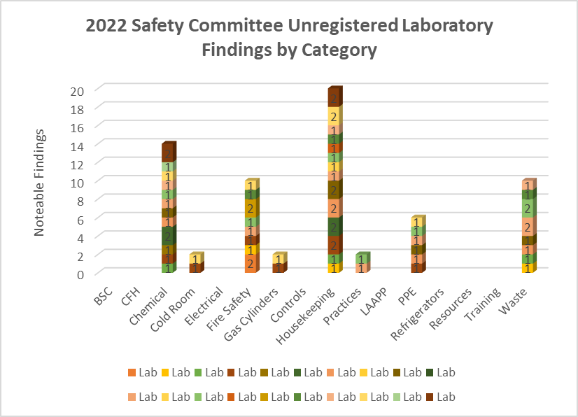

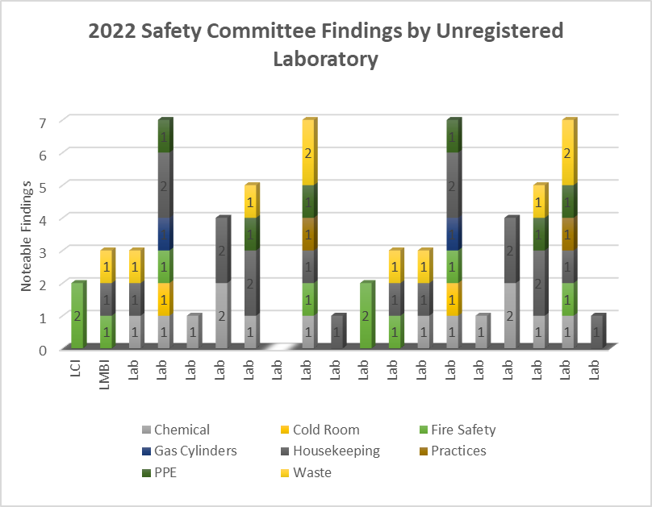
- Corridors (Example chart: Do not include item if category has zero findings)

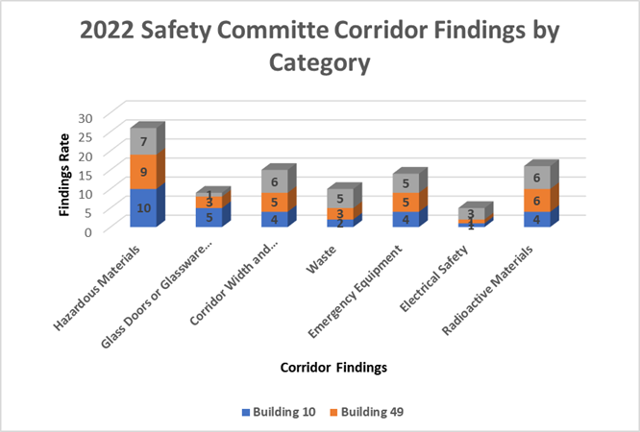

- Offices (Example chart: Do not include item if category has zero findings)

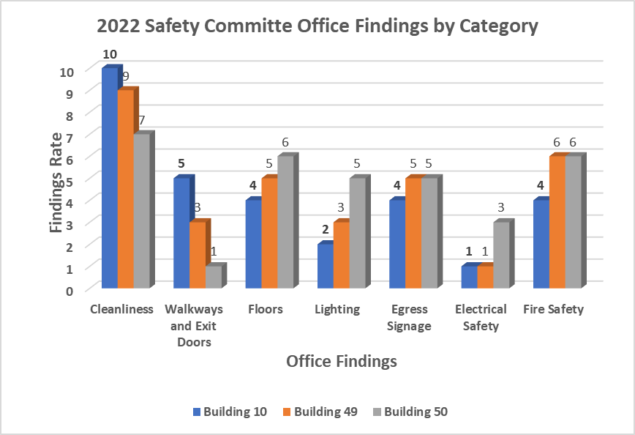

- Yearly Category Comparisons (Example chart: Do not include item if category has zero findings)

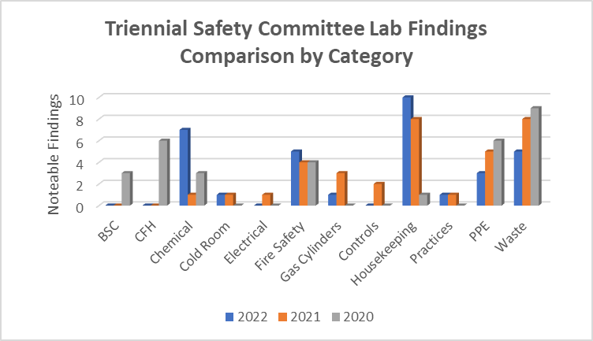

2020 | 2021 | 2022
Total observations = 36  Areas surveyed = 15  Total possible observations = 540 | Total observations = 32  Areas surveyd = 14  Total possible observations = 448 | Total observations = 35  Areas surveyed = 14  Total possible observations = 490

Appendix 2:

Example Table 1: (Total number of labs) Surveys were Conducted
Biological Safety Cabinet (BSC) | Corrective action indicated | Comments
Are biological safety cabinets certified within the last year?  If not, provide last certification date. | 1 | Total number of findings out of possible number of observations out of total lab areas  Example:  1 of 56 possible observations  amongst 14 labs surveyed
Are front grill and exhaust filters unobstructed? | 0
Are open flames not used inside the cabinet? | 0
Do vacuum traps on floors have secondary containment? Do vacuum lines have in-line filters? | 0
Chemical Fume Hood (CFH) and Other Local Exhaust | Corrective action indicated | Comments
Are chemical fume hoods certified within the last year? If not, provide last certification date. | 0
Are air foil and rear baffle unobstructed? | 0
Is the sash at or below the maximum height? | 0
Is the CFH free from any surrounding blockage or obstructions, and not used for storage? | 0 | No corrective action indicated (only added for categories where no Labs/PIs had findings in any of the questions)
Has other local exhaust equipment (e.g., downdraft tables, Laminar flow stations, etc.) been certified? If not, provide last certification date. | 0
Chemicals | Corrective action indicated | Comments
Are all flammables stored in a flammable storage cabinet? | 0
Have peroxide formers been double dated? | 0 | No corrective action indicated
Have chemicals been segregated properly? | 0
Are no hazardous materials stored above eye level? | 0
Are all chemical containers within laboratory securely closed? | 0
Are all solutions properly labeled? | 0
No mercury thermometers are present? | 0
Cold Room | Corrective action indicated | Comments
Does cold room have an emergency release? | 0 | No corrective action indicated
Is emergency POC info present on the outside of the unit? | 0
Is there any excess, unused, or damaged cardboard stored in the cold room? | 0
Asphyxiates and hazardous gases are not present or used? | 0
Electrical | Corrective action indicated | Comments
Are all equipment without frayed or damaged wiring? | 0
Are any outlets or electrical strips overloaded? | 0
Are all computers and power strips mounted off the floor? | 0
Are electrical outlets within 1 meter of water sources protected by G.F.C.I? | 0 | No corrective action indicated
Are there no portable space heaters? | 0
Are there no permanent extension cords? | 0
Are electrical panels and breakers accessible? (Unblocked within 36” of panel)? | 0
Fire Protection | Corrective action indicated | Comments
Are sprinkler heads free of obstructions with an 18" clearance below sprinkler heads? | 0
Are all passage widths in laboratory a minimum of 36"? | 0
Are doors to labs and hazardous storage kept closed to ensure fire protection and directional air flow? | 0 | No corrective action indicated
Are there any excess combustibles stored elsewhere outside of laboratory? | 0
There are no open penetrations in the walls, floor, or ceiling (e.g., ceiling tiles missing etc.)? | 0
Gas Cylinders | Corrective action indicated | Comments
Are all cylinders properly secured? | 0
Are the caps on all reserve cylinders? | 0 | No corrective action indicated
There are no excess or empty cylinders in the laboratory? | 0
General Engineering Controls | Corrective action indicated | Comments
Is laboratory air flow negative to general occupancy, corridor & office areas? | 0
Is the hand washing sink available and unobstructed? | 0 | No corrective action indicated
Do vacuum lines on lab benches and in BSCs have in-line filters and disinfectant traps? | 0

General Laboratory Housekeeping | Corrective action indicated | Comments
Are there any glass containers being stored on the floor? | 0
Are all slip, trip, or fall hazards removed from laboratory? | 0 | No corrective action indicated
Are clean absorbent pads located on work surfaces? | 0
Does the laboratory appear to be clean and uncluttered? | 0
Is the lab using proper disinfectant and disinfecting procedures? | 0
General Practice and Procedures | Corrective action indicated | Comments
Food intended for human consumption is not stored in laboratory areas. | 0
Are microwave oven(s) clearly labeled "No Food Preparation, “Lab Use Only"? | 0
Has proper signage (i.e. UV, Laser, Radioactive, etc.) been displayed on the laboratory door? | 0 | No corrective action indicated
Is proper Emergency 1-2-3 poster displayed in the laboratory? | 0
Has lab equipment been properly labeled (Biohazard, Radioactive, Toxic, etc.)? | 0
Are all furniture items within the lab nonporous (i.e., chairs, no rugs, no cloth bulletin boards)? | 0
There are no Air Quality concerns (e.g., odors, uncomfortable conditions, etc.)? | 0
Laboratory Animal Program | Corrective action indicated | Comments
Are all transport containers, animal waste, and carcasses properly contained? | 0 | No corrective action indicated
Have all rooms in which animals are present been posted with a LAAPP sign? | 0
Personal Protective Equipment (PPE) | Corrective action indicated | Comments
Is eyewash available in lab, unobstructed and flushed weekly? | 0
Is a safety shower available, unobstructed, and flushed within the past 12 months? If not, provide last certification date. | 0 | No corrective action indicated
Is Personal protective equipment available (gloves, gowns, goggles, etc.) and being used? | 0
Are occupants properly attired? (i.e. no exposed skin, closed toe shoes)? | 0
Refrigerators-Freezers | Corrective action indicated | Comments
Refrigerated flammables are stored only in hazard-rated unit? | 0 | No corrective action indicated
Safety Resources | Corrective action indicated | Comments
Are SOP's readily available in the lab? | 0
Has lab staff been notified of NIH CHP/ECP? | 0 | No corrective action indicated
Has lab staff been notified on how to report hazardous conditions? | 0
Has the lab staff received the Chemical Safety Guide? | 0
Safety Training | Corrective action indicated | Comments
Are all lab staff up to date with Lab Safety Training and BBP training (Initial & Refresher)? | 0 | No corrective action indicated
Have all personnel read, reviewed, and followed instructions on laboratory practices and procedures? | 0
Waste Management | Corrective action indicated | Comments
There is no evidence of any form of improper waste disposal? | 0 | No corrective action indicated
Are Chemical wastes tagged, labeled, dated <60 days and kept closed? | 0
Are chemical waste containers in secondary containment? | 0
Are sharps containers being used properly and disposed of as MPW when ¾ full? | 0
Has waste disposal guide been displayed in the laboratory? | 0
Are any MPW boxes overfilled past ¾ or not double bagged? | 0

